Day 1 (10/5/26, 2 hours, 5 minutes):
Getting Started

Today, I started off by installing KiCad, and cloning the Starbie Repo to learn the basics of creating a PCB. I imported the .KiCad_sym file, and the .pretty file into KiCad as well.

Then, I started on the PCB element of the project, replicating the components from the GitHub page.
KiCad is pretty intuitive! It might just be from some of my experience from blender, but the software was pretty easy to work with! (I don’t trust myself to make anything sophisticated with it yet tho. :( )

When I had to start editing the footprints, KiCad did seem to struggle a bit, and crashed a couple of times while I tried to get it to work. I did manage to get the footprint assigner to open, after a bit of finagling (It’s probably just my computer though, I’ve had it since 2019, and I’ve been putting it through the ringer recently, with all of the new skills I’ve been trying to develop :/ ).
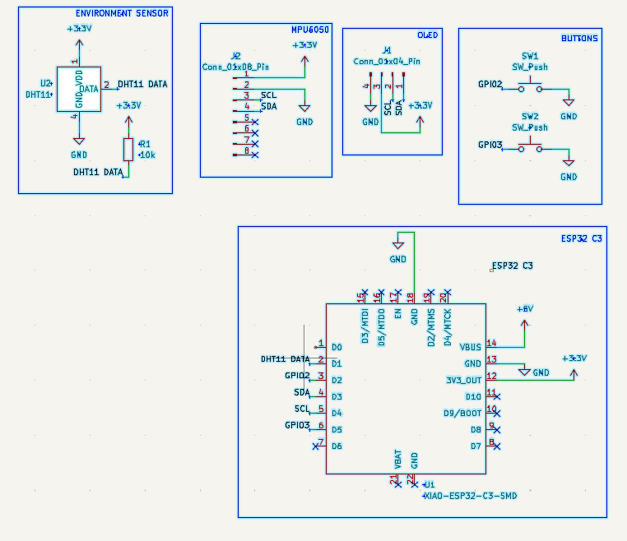

Here are the schematics that I worked on →

After that, I went to the PCB editor, and dumped the schematics onto the page. After I finished up with the custom boundary, I faced my most daunting challenge yet, routing the PCB. (I spent wayyy too much time finding the best way to get everything to fit, and it still gave me some trouble….)
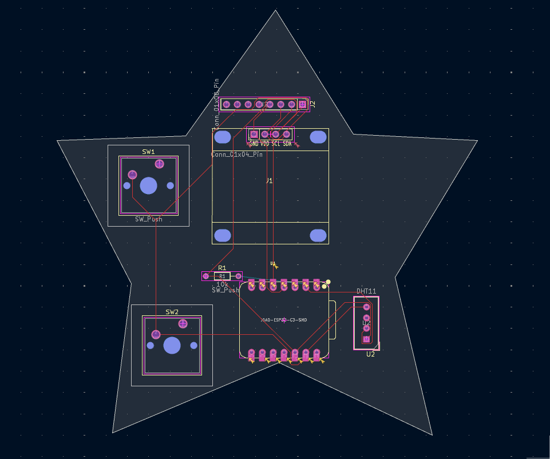

The fruits of my labor ----->

Once I finished with the routing, I decided to check up on the DRC, and unfortunately…
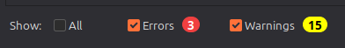

Yeah.

I decided to hit the hay, and deal with the rest of this tomorrow.

PROGRESS FOR DAY 1:
-Installed KiCad
-Finished with Schematics
-Started on PCB
(I also wrote the script for the short today! I didn’t include it in the time though, since it was after my timer went up.)

Day 2 (10/6/2026, 1 hour, 9 minutes. )

I return to the project rejuvenated. REJUVENATED I TELL YOU!

I started off by removing all of the routing that I did the previous day. I assume that that’s the main thing causing the issues, alongside my choice to mess with the shape of the PCB.

Then, I reorganized the components like how they were arranged on the tutorial. If I have time, Ill look into why certain formats are better than others, but that’s a pretty big if, since I‘ve been stupid busy.

I fixed the outline after I got everything back in place, and then started on redoing the routing.

And at long last… I finished with the PCB.

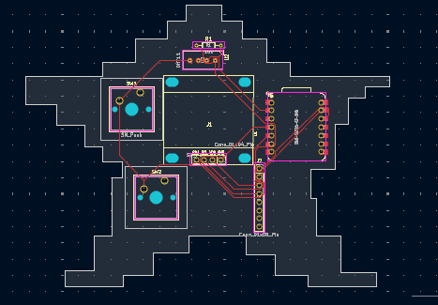

Well, not entirely…

I still want to add some images to it...

But that can come later. I want to take care of the firmware first.

I installed the arduino IDE, but I had some technical difficulties with getting it to work,

It ABSOLUTELY refused to load, and I attempted to reinstall it, to no avail.

I then started trying older builds to see if those would work, and luckily, I was able to get 1.8.19 working.

I then decided to try the most recent build again, and then it magically started working. (if I had to guess, it was probably a dependancy issue, which got fixed when I installed the earlier version. I could be wrong though :/)

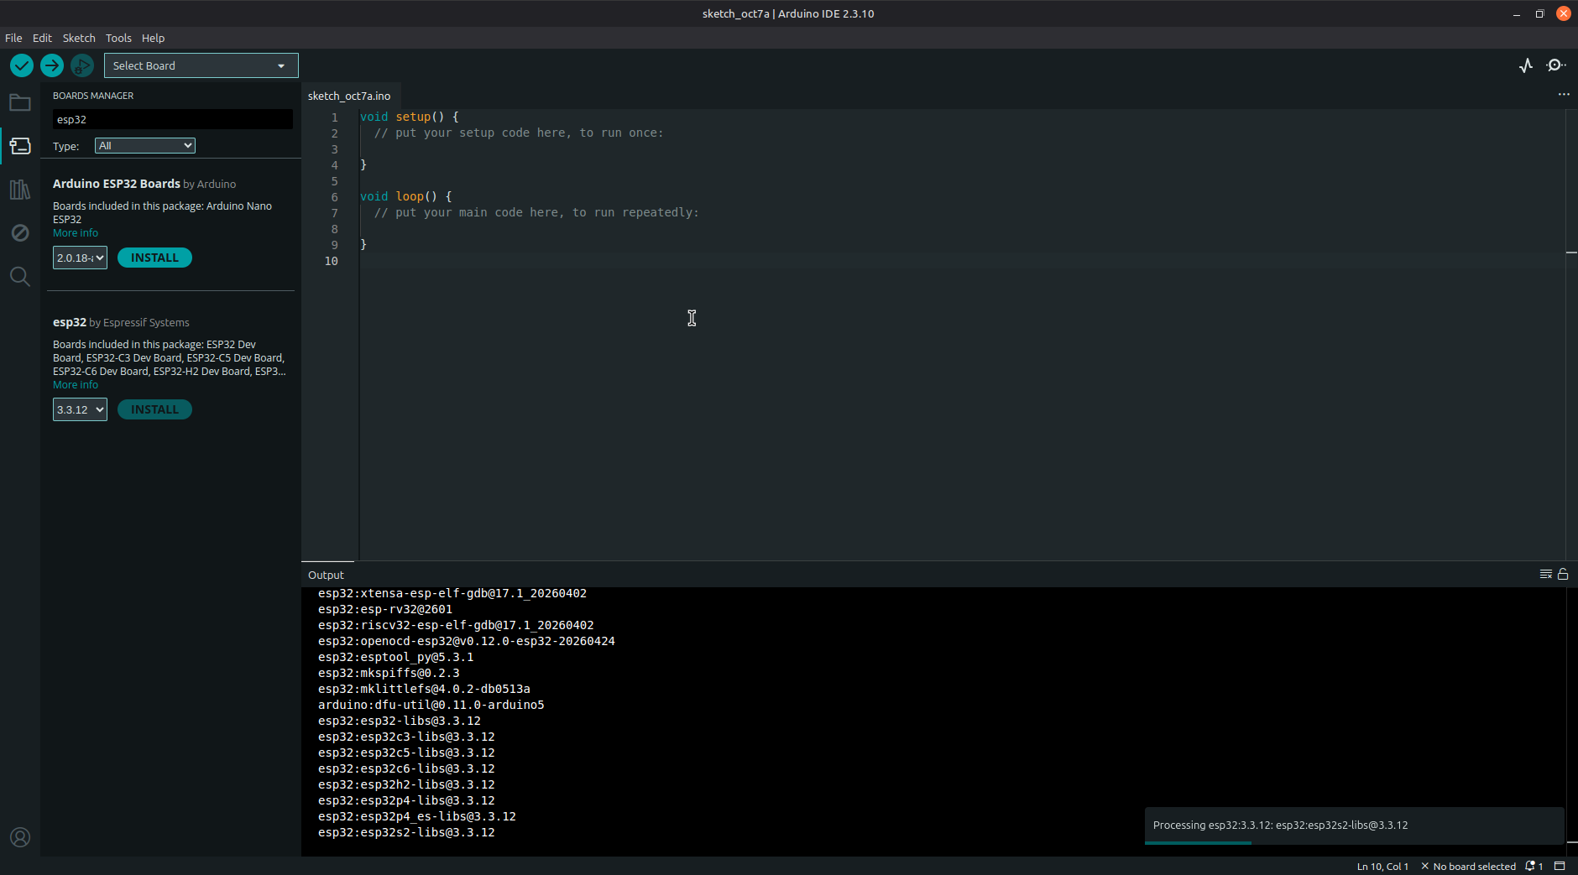
...Here’s it in action (I’m also downloading the ESP32 stuff as well!)

After that, I finished with installing the rest of the libraries. The only thing that’s left is just adding my own personal touch to the project!
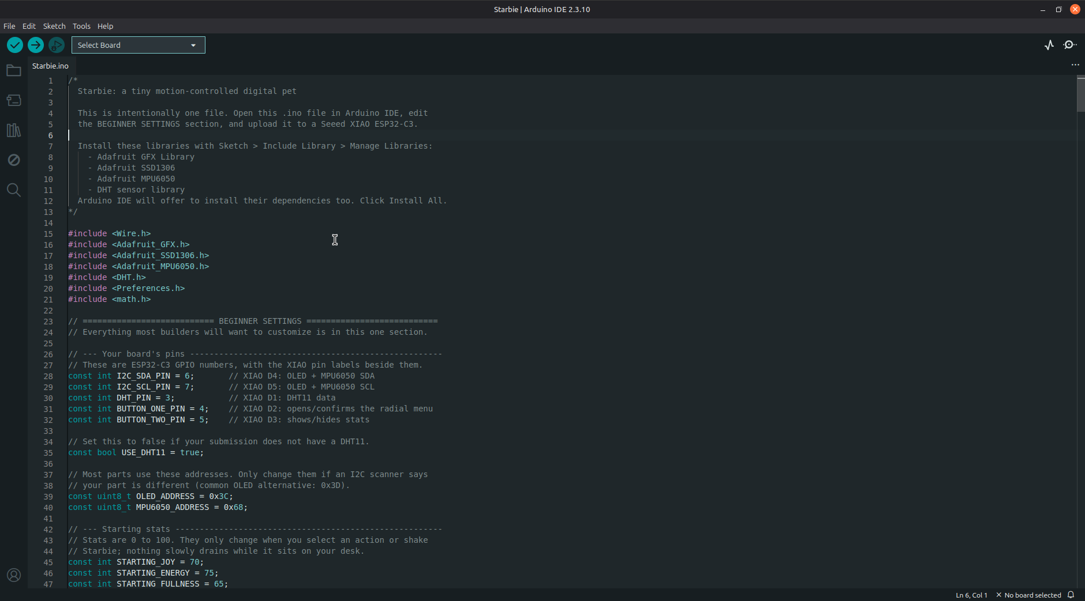
(This is where I stopped off for day 2)

Day 3 (10/8/26)

I started by grabbing a couple of the images I wanted to add onto my board. I mostly just picked stuff at random, but I did add a couple things that I drew myself there as well!

I wanted to try to figure out how to add images myself, and not rely on google too much, so I first tried converting the images into icon files. I then tried to add it directly to the board, and I didn’t see anything that would allow me to add the images.
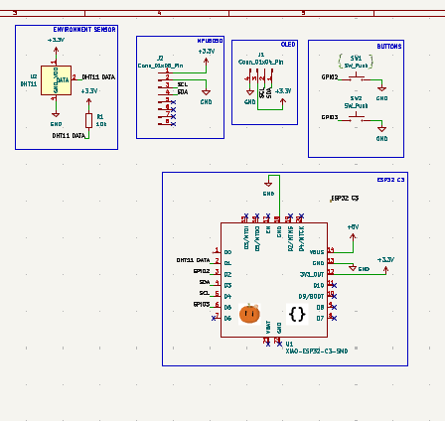
Then, I tried adding the images to the schematics, and I didn’t have to convert the images to a icon, and could add them as a png.

The images on the schematic ->

Unfortunately, that didn’t seem to work, so I was back to the drawing board.

I then tried to use the converted images on the schematics, but that didn’t show up on the PCB either.

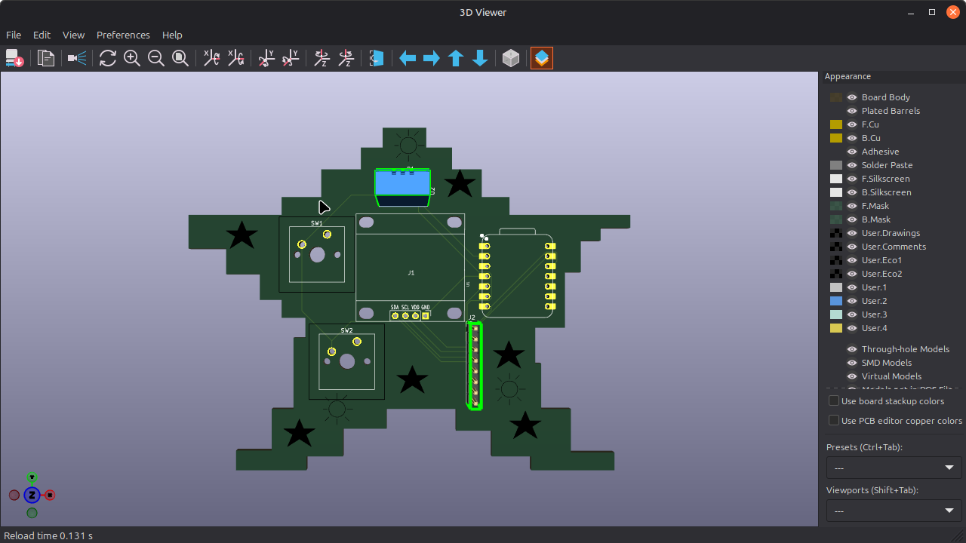
I still couldn’t figure out how to add images, so I decided to settle for some small little sketches on the board.

I decided to shelve the image thing for now. (Maybe I’ll come back to it at the beginning of week 5? or ill try and fit it in this week, idk)

Naturally, I wanted to try some of the modifications listed on the github page, namely adding a special effect, and drawing my own bitmap pet.

I opened the file, and then decided that it would also be fun to tweak a couple of the variables, namely the ones pertaining to the behavior. After that, I tried to mess with the image, but I felt a little lost, mostly because I wasn’t sure if it wanted a spritesheet passed to it, but I found out that wasn’t the case, and got to making my little guy.
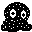
There he is! →

I then used the image to cpp tool linked on the github page to convert the image into a byte array, which I then pasted into the starbie.ino file.

After that, I just added in the sparkles. As I don’t currently have everything I need to make the starbie, I didn’t really edit it, but I did make a small droplet image that ill eventually use instead of the sparkles.

